https://gitlab.tcsbank.ru/das/freeipa-client
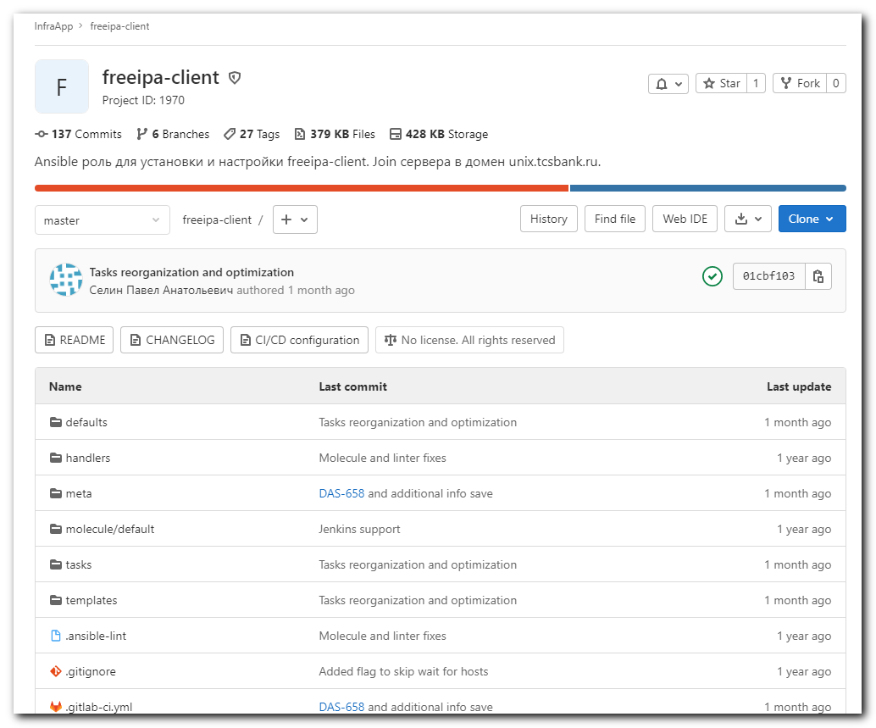

[s.belogrud@nb2339]# git clone ssh://git@gitlab.tcsbank.ru:7999/das/freeipa-client.git
Клонирование в «freeipa-client»…
stty: standard input: Inappropriate ioctl for device
remote: Enumerating objects: 685, done.
remote: Counting objects: 100% (37/37), done.
remote: Compressing objects: 100% (28/28), done.
remote: Total 685 (delta 12), reused 31 (delta 6), pack-reused 648
Получение объектов: 100% (685/685), 100.03 KiB | 386.00 KiB/s, готово.
Определение изменений: 100% (360/360), готово.
[s.belogrud@nb2339]#

[s.belogrud@nb2339]# mv freeipa-client/* ./
[s.belogrud@nb2339]# mv freeipa-client/.
./ ../ .ansible-lint .git/ .gitignore .gitlab-ci.yml .yamllint
[s.belogrud@nb2339]# mv freeipa-client/.git* ./
[s.belogrud@nb2339]# mv freeipa-client/.ansible-lint* ./
[s.belogrud@nb2339]# mv freeipa-client/.yamllint* ./
[s.belogrud@nb2339]# rmdir freeipa-client/
[s.belogrud@nb2339]#

[s.belogrud@nb2339]# vim .git/config
[s.belogrud@nb2339]# cat .git/config
[core]
repositoryformatversion = 0
filemode = true
bare = false
logallrefupdates = true
ignorecase = true
[remote "origin"]
url = ssh://git@gitlab.tcsbank.ru:7999/das/freeipa-client.git
fetch = +refs/heads/*:refs/remotes/origin/*
[branch "master"]
remote = origin
merge = refs/heads/master
[ssh]
identity = /home/mobaxterm/.ssh/id_rsa_s.belogrud
[s.belogrud@nb2339]#

[support@nb2339]# cd roles/das/freeipa-client/

[support@nb2339]# python3 -m venv env
[support@nb2339]#

[support@nb2339]# source env/bin/activate
(env) [support@nb2339]#

(env) [support@nb2339]# ansible-galaxy install -r requirements.yml -p ./roles/
Traceback (most recent call last):
File "/usr/bin/ansible-galaxy", line 34, in <module>
from ansible import context
ModuleNotFoundError: No module named 'ansible'
(env) [support@nb2339]# pip install -Ur requirements.txt

(env) [support@nb2339]# pip install -Ur requirements.txt
ERROR: Could not open requirements file: [Errno 2] No such file or directory: 'requirements.txt'
(env) [support@nb2339]# pip install -Ur requirements.yml
Usage: pip [options]

ERROR: Invalid requirement: ---
pip: error: no such option: ---

(env) [support@nb2339]# ansible-galaxy install -r ./requirements.yml -p ./roles/
Traceback (most recent call last):
File "/usr/bin/ansible-galaxy", line 34, in <module>
from ansible import context
ModuleNotFoundError: No module named 'ansible'
(env) [support@nb2339]#

(env) [support@nb2339]# deactivate
[support@nb2339]# rmdir roles

[support@nb2339]# export ANSIBLE_CONFIG=roles/ansible/unix-common/ansible.cfg ; logfile="$(date +%Y%m%d-%H%M).playbook.log.txt" ; ansible-playbook 20211008-1931.freeipa-client.yml -i list_of_hosts --become --extra-vars "ansible_user=root ansible_password=$(pass common/linux-root) ansible_ssh_common_args='-oStrictHostKeyChecking=no -oPubkeyAuthentication=no -oUserKnownHostsFile=/dev/null'" | tee -a ./output/${logfile}
[WARNING]: Ansible is being run in a world writable directory (/mnt/c/data/work/ansible/gitlab.tcsbank.ru), ignoring it as an
ansible.cfg source. For more information see https://docs.ansible.com/ansible/devel/reference_appendices/config.html#cfg-in-world-
writable-dir
ERROR! the role 'ansible-role-chrony' was not found in /mnt/c/data/work/ansible/gitlab.tcsbank.ru/roles:/home/support/.ansible/roles:/usr/share/ansible/roles:/etc/ansible/roles:/mnt/c/data/work/ansible/gitlab.tcsbank.ru/roles/das:/mnt/c/data/work/ansible/gitlab.tcsbank.ru

The error appears to be in '/mnt/c/data/work/ansible/gitlab.tcsbank.ru/roles/das/freeipa-client/meta/main.yml': line 23, column 5, but may
be elsewhere in the file depending on the exact syntax problem.

The offending line appears to be:

dependencies:
- name: ansible-role-chrony
^ here
[support@nb2339]#

#
# It's need not to use "source ..." to run this command.
#
[support@nb2339]# ansible-galaxy install -r requirements.yml -p ./roles/
- extracting ansible-role-chrony to /mnt/c/data/work/ansible/gitlab.tcsbank.ru/roles/das/freeipa-client/roles/ansible-role-chrony
- ansible-role-chrony (v1.0.0) was installed successfully
[support@nb2339]# ls -Alh ./roles/
total 0
drwxrwxrwx 1 support support 512 Oct 8 20:00 ansible-role-chrony
[support@nb2339]#

# If I want update dependent role.
[support@nb2339]# ansible-galaxy install -r ./requirements.yml -p ./roles/
[WARNING]: - ansible-role-chrony (v1.0.0) is already installed - use --force to change version to v1.0.1
[support@nb2339]# ansible-galaxy install -r ./requirements.yml -p ./roles/ --force
- changing role ansible-role-chrony from v1.0.0 to v1.0.1
- extracting ansible-role-chrony to /mnt/c/data/work/ansible/gitlab.tcsbank.ru/roles/das/freeipa-client/roles/ansible-role-chrony
- ansible-role-chrony (v1.0.1) was installed successfully
[support@nb2339]#

[support@nb2339]# pwd
/mnt/c/data/work/ansible/gitlab.tcsbank.ru
[support@nb2339]#

[support@nb2339]# export ANSIBLE_CONFIG=ansible.cfg ; logfile="$(date +%Y%m%d-%H%M).playbook.log.txt" ; ansible-playbook 20211008-1931.freeipa-client.yml -i list_of_hosts --become --extra-vars "ansible_user=root ansible_password=$(pass common/linux-root) ansible_ssh_common_args='-oStrictHostKeyChecking=no -oPubkeyAuthentication=no -oUserKnownHostsFile=/dev/null'" | tee -a ./output/${logfile}

